Supplementary Materials for:

Cognitive Music Listening Space: A Multivariate Approach

Brendon Mizener1, Mathilde Vandenberghe2, Hervé Abdi1, & Sylvie Chollet2

1 University of Texas at Dallas

2 Junia, Univ. Artois, Université de Liège, Univ. Littoral Côte d’Opale, UMRT 1158 BioEcoAgro, F-62000 Arras, France

# List of Figures

1. MDS results for participants in Experiment 1, colored according to nationality (left) and gender identity (right). 4
2. Hierarchical cluster analysis for the row factor scores of the CA for Experiment 1. 5
3. Hierarchical cluster analysis for the row factor scores of the CA for Experiment 1 including Excerpts 6 and 14. 6
4. CA: Row factor scores for preliminary analysis of the qualities survey, featuring Dimensions 1

and 2, with tolerance intervals around the clusters identified by the HCA. 7

1. CA: Row factor scores for the preliminary analysis of the qualities survey, featuring Dimensions

2 and 3, with tolerance intervals around the clusters identified by the HCA. 8

1. CA: Column factor scores for the analysis of the qualities survey, points are levels of each variable, colored by variable. 9
2. Separate factor score plots for each of the qualities evaluated in the musical qualities survey. Each plot comprises the same space for the sake of comparison 10
3. All signed contributions for the first two dimensions of the CA for the Qualities Survey 12
4. Hierarchical cluster analysis for the row factor scores of the CA for Experiment 2. 14
5. Hierarchical cluster analysis for the column factor scores of the CA for Experiment 2. 15
6. CA: Adjectives Survey, row and column factor scores plotted on the same map. 16
7. CA: All signed contributions for the first two dimensions of the CA of the Adjectives survey, ordered according to their magnitude. 17
8. PLSC: Correlation matrix for the columns of the surveys from Experiments 1 and 2. Correlation values between variables are indicated by color and opacity. Dark blue is a strong positive correlation and dark red is a strong negative correlation, pale or white squares indicate little to no correlation. 18
9. All signed loadings for the first two LVs of the PLSC. Colored according to their color schemes from Experiments 1 and 2. 19

# List of Tables

1. Musical Qualities and the provided survey response options, English. 2
2. Musical Qualities and the provided survey response options, French. 3
3. CATA Adjectives 13

2

# Supplementary Materials: Experiment 1

Table 1: Musical Qualities and the provided survey response options, English.

|  |  |  |  |  |  |
| --- | --- | --- | --- | --- | --- |
| Harmonic Material | Tempo | Meter | Density | Genre | Articulation |
| Diatonic: Major | Very slow | Simple Duple | Very sparse | Baroque | Staccato |
| Diatonic: Minor | Slow | Simple Triple | Moderately sparse | Classical | Marcato |
| Blues | Moderately Slow | Simple Quadruple | More sparse than dense | Romantic | Legato |
| Chromatic | Moderate | Compound Duple | More dense than sparse | Impressionist | Tenuto |
| Whole tone | Moderately Fast | Compound Triple | Moderately Dense | Modern | Other |
| Modal | Fast | Compound Quadruple | Very Dense | Jazz/Blues |  |
| Quintal/Quartal | Very Fast | Complex |  | Contemporary |  |
| Ambiguous |  |  |  | Other |  |
| Other |  |  |  |  |  |
|  | Contour | Motion | Range | Dynamics |  |
|  | Ascending | Conjunct | Narrow | Soft |  |
|  | Descending | Disjunct | Moderate | Moderate |  |
|  | Arch | Combination of conjunct | Wide | Loud |  |
|  | Undulating | and disjunct | Very Wide | Varied: gradual crescendo |  |
|  | Pendulum | I do not think this | I do not think this | Varied: gradual |  |
|  | Terrace | excerpt has a melody | excerpt has a melody | decrescendo |  |
|  | I do not think this | Other |  | Some of each, soft and |  |
|  | excerpt has a melody |  |  | loud |  |
|  | Other |  |  | Other |  |

3

Table 2: Musical Qualities and the provided survey response options, French.

|  |  |  |  |  |  |
| --- | --- | --- | --- | --- | --- |
| Harmonie | Vitesse | Mesure | Densité | Genre | Articulation |
| Diatonique: majeur | Très lente | Mesure simple, deux temps | Très épurée | Baroque | Staccato |
| Diatonique: mineur | Lente | Mesure simple, trois temps | Modérément épurée | Classique | Marcato |
| Gamme Blues | Moyennement lent | Mesure simple, quatre temps | Plutôt épurée que dense | Romantique | Legato |
| Chromatique | Moyenne | Mesure composée, deux temps | Plutôt dense qu’épurée | Impressioniste | Tenuto |
| Gamme par ton | Moyennement rapide | Mesure composée, trois temps | Moyennement dense | Moderne | Autre (précisez) |
| Modal | Rapide | Mesure composée, quatre temps | Très dense | Jazz-Blues |  |
| Ambigu | Très rapide | Mesure complexe |  | Contemporarain |  |
| Je ne pense pas que cet |  |  |  | Autre (précisez) |  |
| extrait ait une mélodie |  |  |  |  |  |
| Autre (précisez) |  |  |  |  |  |
|  | Contour | Mouvement | Ambitus | Dynamiques |  |
|  | Ascendant | Conjoint | Ambitus resserré | Doux |  |
|  | Descendant | Disjoint | Ambitus modéré | Moyen |  |
|  | Forme en arche | Une combinaison de | Ambitus grand | Fort |  |
|  | Petites vagues successives | conjoint et disjoint | Ambitus très grand | Varié : crescendo |  |
|  | Grandes vagues | Je ne pense pas que cet | Je ne pense pas que cet | progressif |  |
|  | successives | extrait ait une mélodie | extrait ait une mélodie | Varié : decrescendo |  |
|  | Plusieurs phases | Autre (précisez) |  | progressif |  |
|  | descendantes successives |  |  | Un peu des deux: doux |  |
|  | Je ne pense pas que cet |  |  | et fort |  |
|  | extrait ait une mélodie |  |  | Autre (précisez) |  |
|  | Autre (précisez) |  |  |  |  |

*Figure 1.* MDS results for participants in Experiment 1, colored according to nationality (left) and gender identity (right).

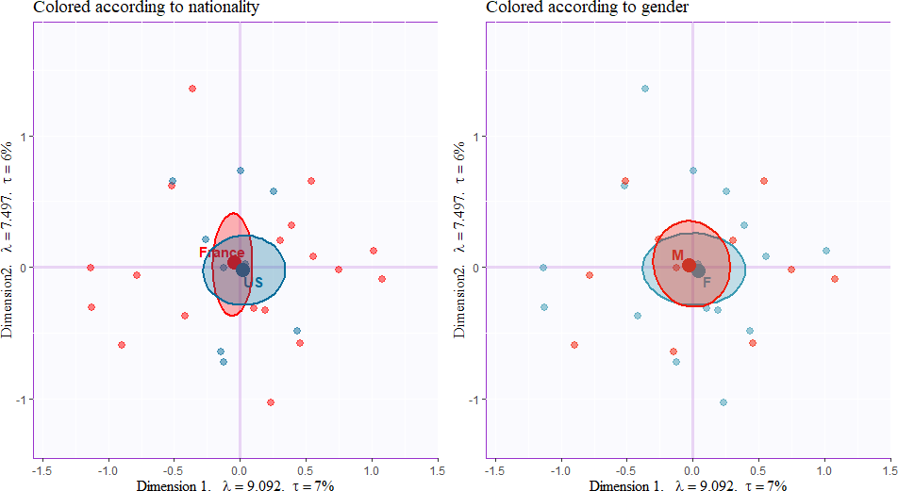

*Figure 2.* Hierarchical cluster analysis for the row factor scores of the CA for Experiment 1.

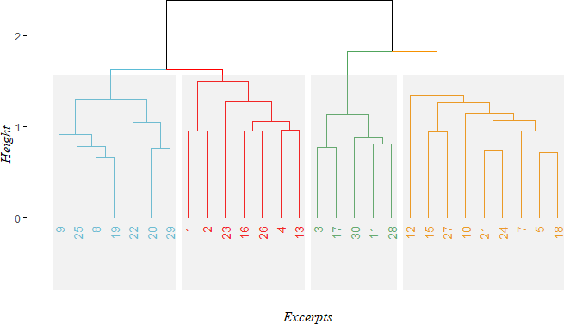

*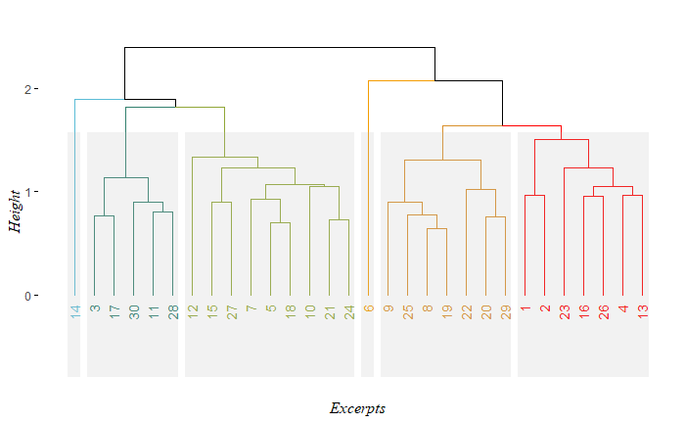**Figure 3*. Hierarchical cluster analysis for the row factor scores of the CA for Experiment 1 including Excerpts 6 and 14.

*Figure 4*. CA: Row factor scores for preliminary analysis of the qualities survey, featuring Dimensions 1 and 2, with tolerance intervals around the clusters identified by the HCA, and colored according to the HCA.

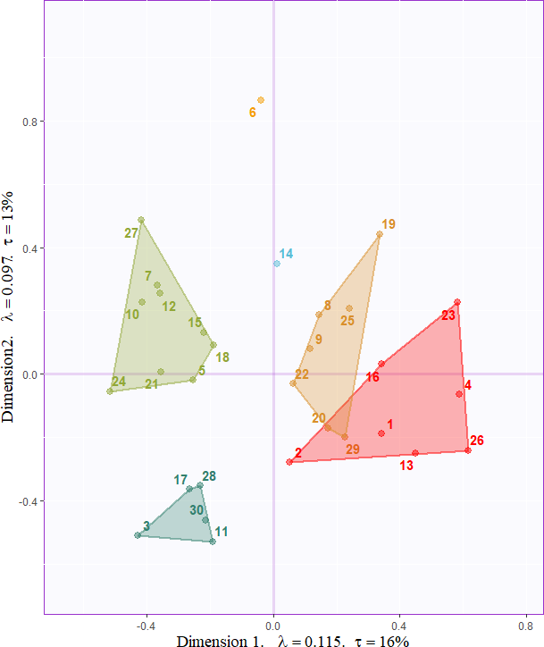

.

*Figure 5.* CA: Row factor scores for the preliminary analysis of the qualities survey, featuring Dimensions 2 and 3, with tolerance intervals around the clusters identified by the HCA.

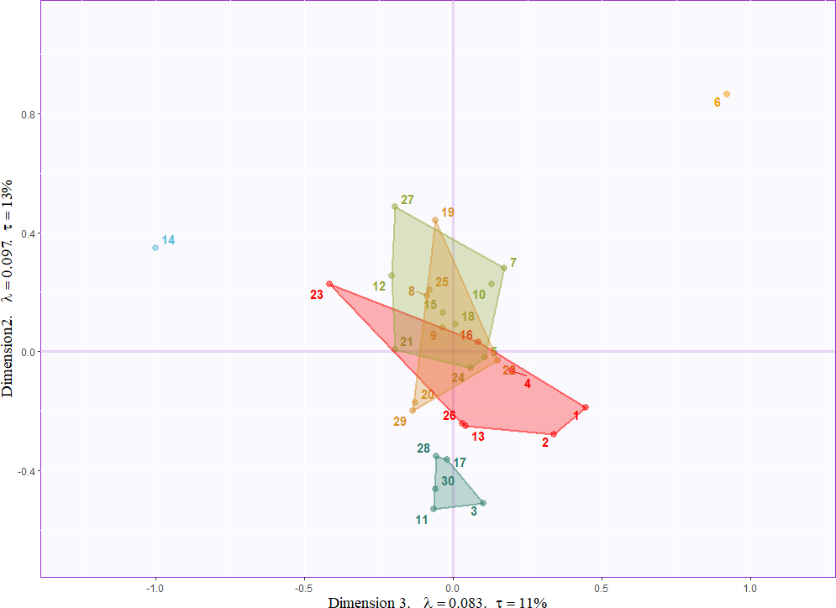

*Figure 6.* CA: Column factor scores for the analysis of the qualities survey, points are levels of each variable, colored by variable.

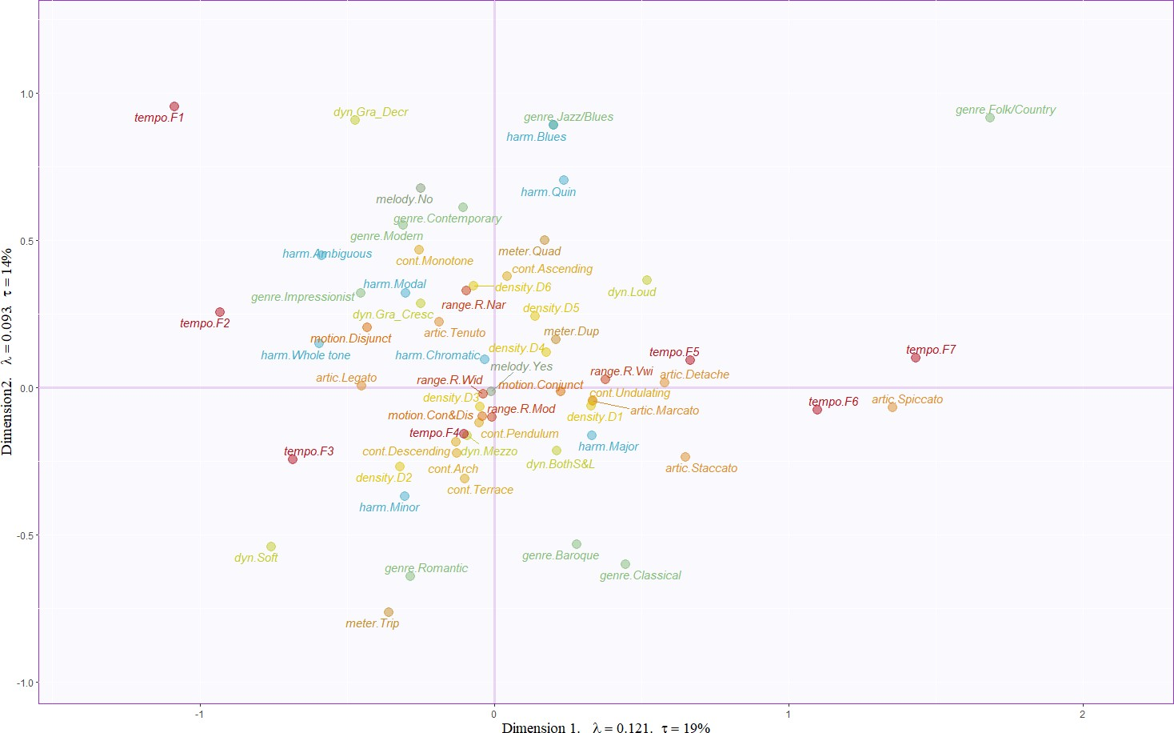

*Figure 7*. Separate factor score plots for each of the qualities evaluated in the musical qualities survey. Each plot comprises the same space for the sake of comparison.

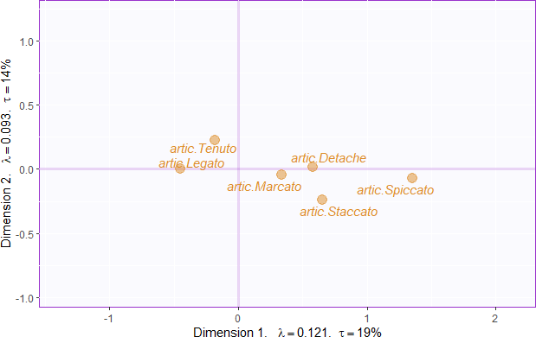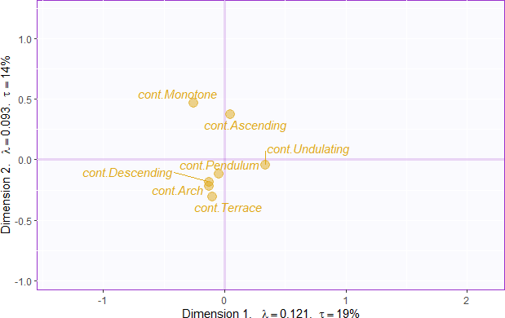

* 1. Articulations (b) Contour

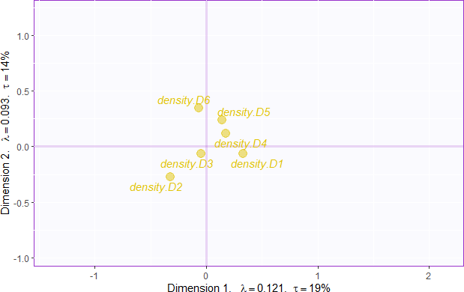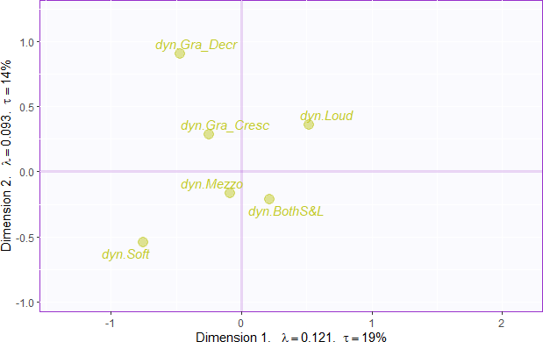

(c) Density (d) Dynamics

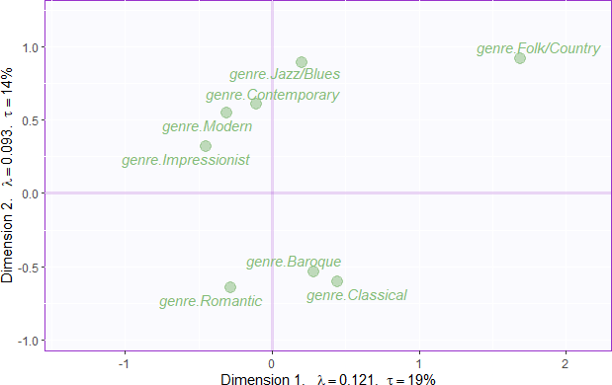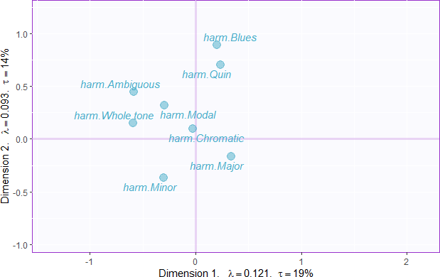

(e) Genre (f) Harmony

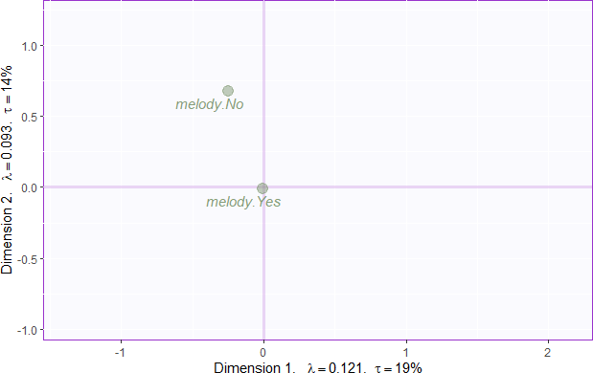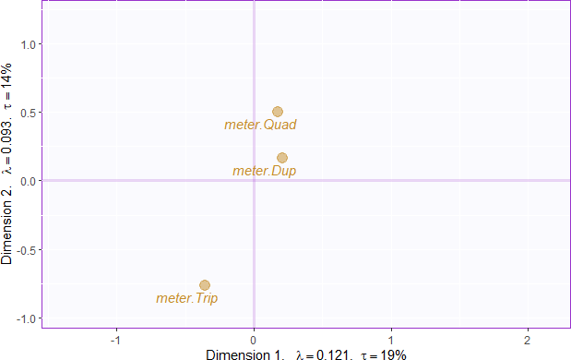

(g) Melody (h) Meter

*Figure 7.* (continued)

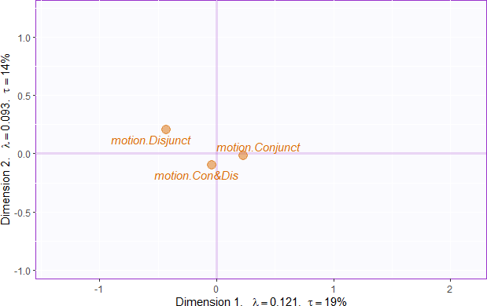 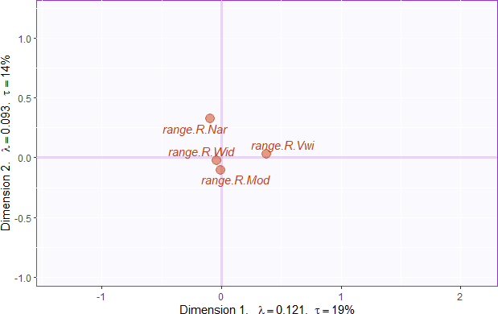

(i) Motion (j) Range

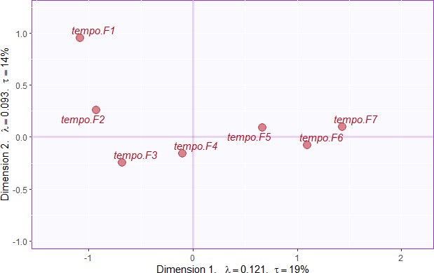

(k) Tempo

*Figure 8*. All signed contributions for the first two dimensions of the CA for the Qualities Survey.

# 

# Supplementary Materials: Experiment 2

Table 3. CATA Adjectives English French

Slow Lent

Fast Rapide

Dense Bavard

Sparse Epuré

Complex Complexe Transparent Transparent Light Clair

Dark Sombre

Bright Brillant

Dull Terne

Soft Doux

Strong Fort Mysterious Mysterieux Melancholy Mélancolique Incisive Incisif

Round Tendre Aggressive Agressif Weak Faible

Strong Puissant

Warm Chaleureux

Solemn Solennel

Valiant Vaillant

Sad Triste

Happy Joyeux

Dancing Dansant Disturbing Inquiétant Exotic Exotique

Colorful Coloré

Varied Changeant Monotonous Monotone Long Long

Short Court Surprising Surprenant

*Figure 9* Hierarchical cluster analysis for the row factor scores of the CA for Experiment 2.

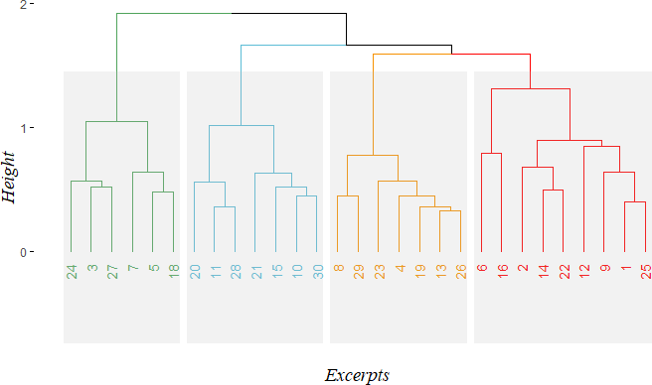

*Figure 10*. Hierarchical cluster analysis for the column factor scores of the CA for Experiment 2.

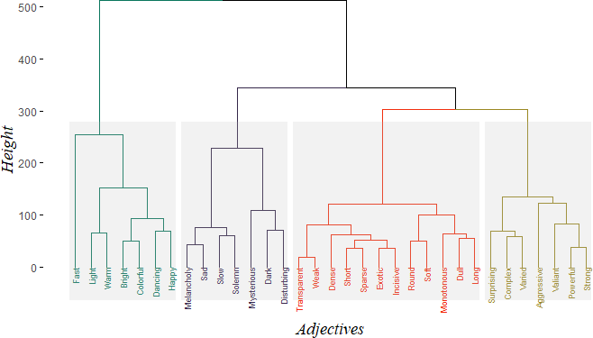

*Figure 11.* CA: Adjectives Survey, row and column factor scores plotted on the same map.

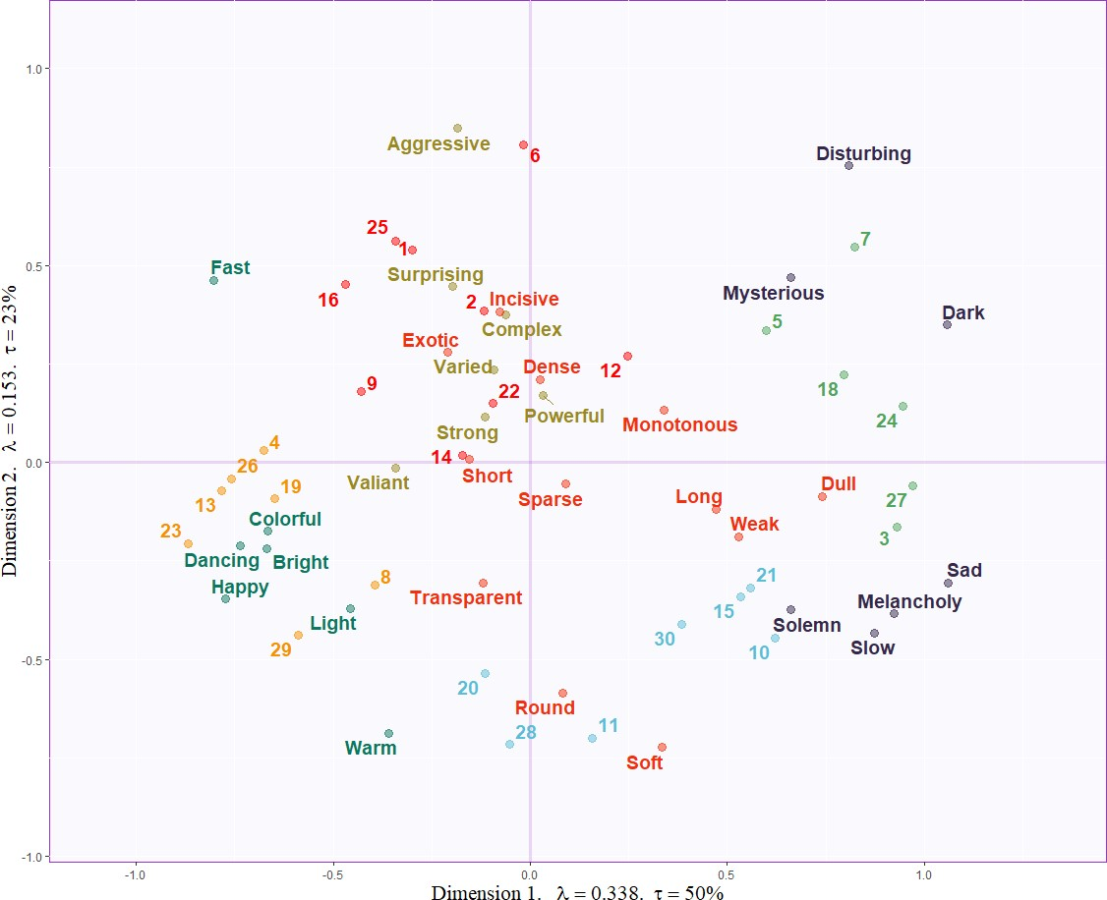

*Figure 12.* CA: All signed contributions for the first two dimensions of the CA of the Adjectives survey, ordered according to their magnitude.

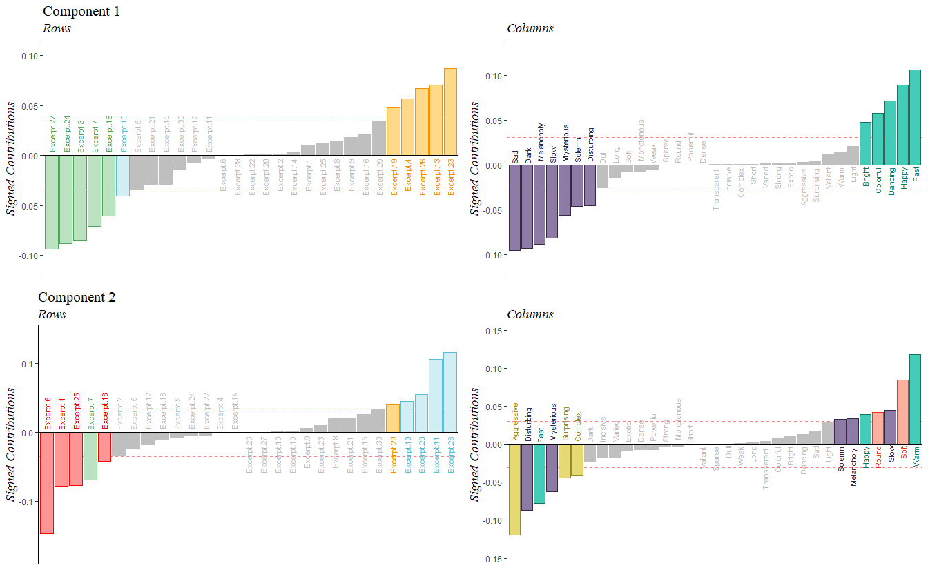

# Supplementary Materials: Experiment 3

*Figure 13.* PLSC: Correlation matrix for the columns of the surveys from Experiments 1 and 2. Correlation values between variables are indicated by color and opacity. Dark blue is a strong positive correlation and dark red is a strong negative correlation, pale or white squares indicate little to no correlation.

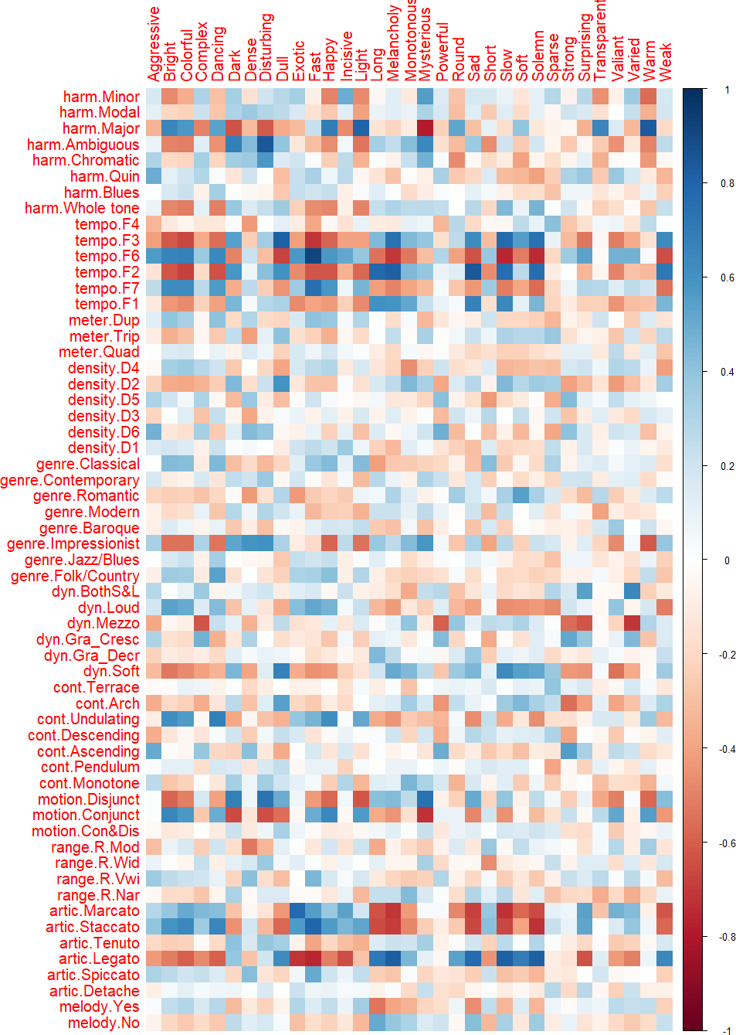

*Figure 14*. All signed loadings for the first two LVs of the PLSC. Colored according to their color schemes from Experiments 1 and 2.

.